Session 1

Identification, Protection and Exploitation of Intellectual Property Rights

Mr Stephen Holmes was a trained optometrist whose experience of using glass for the manufacture of lenses was that materials are both costly to manufacture and heavy to transport in bulk. His family had been in the plastics business for generations, and he had been working on the development of progressive power acrylic lenses which were extremely lightweight, but which nevertheless would still be quite costly to manufacture in his home country. His family had strong business connections with various manufacturers and Mr Holmes decided to create the Polycon Lens Company. He recruited one of his contacts to develop the business there as regards the manufacture of spectacles, and introduced a wholesaler in his home country to the Polycon employee which was prepared to guarantee a minimum purchase order to justify the cost of the new plant required. Ultimately, Mr Holmes’s idea was to attempt to penetrate the market for white label designer glasses for well-known brands for the consumer market, but the marketing and selling costs could not be afforded at the outset. Thus, the wholesaler would currently find customers worldwide for the products, so that in the initial stages Polycon Lens Company was simply a manufacturing company.

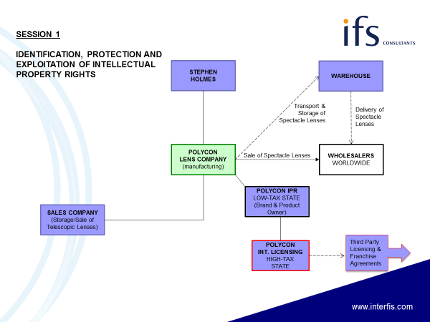

Session 2

Research & Development Tax Credits and Patent Box Regimes

Polycon Lens Company was showing reasonable profits from manufacturing non-individualised progressive power spectacles and selling them to wholesalers for distribution to the general public. Instead of paying a dividend out of these profits, the company decided to use most of its profits to fund a research and development programme into the manufacture of high quality optical lenses for telescopic use, primarily aimed at the armed services market. Mr Holmes believed that through his contacts at home, he can generate considerable interest in the potential exports of these lenses throughout Europe and North America. The directors agreed to open a small office not far from where Mr Holmes lived, which could have several uses. It could provide a place to store a small stock of lenses for display purposes in their telescopic application, and also could present and circulate products and relevant literature to interested potential customers. The directors of Polycon Lens Company also asked Mr Holmes if he could find an agent to undertake marketing activities, and to pass on any enquiries for potential sales of the lenses back to Polycon.

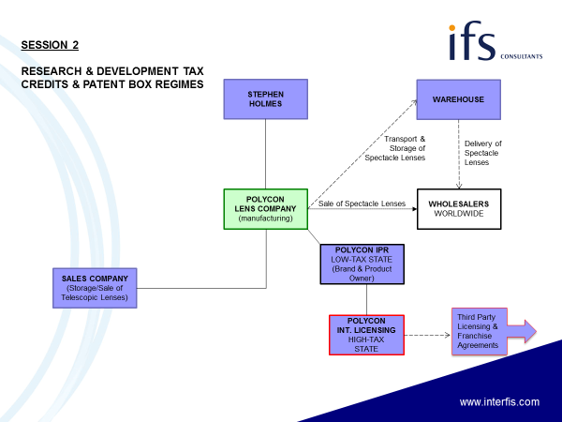

Session 3

International VAT Pitfalls & Developments

The directors are disappointed that the agent Mr Holmes has introduced them to, is not particularly good at marketing such a highly technical product and believe that the only way to maximise the product’s potential is to employ dedicated sales staff for this purpose. The office Mr Holmes has opened as a representative office is large enough to accommodate the number of additional staff that are required, and Mr Holmes has identified salesmen who are also technicians, and who would be able to converse with customers explaining the technical aspects of the lenses.

As regards the distribution of the spectacles, contracts have been entered into with many new wholesalers who are located in several countries. As a result, the transport costs have increased considerably and are making substantial inroads into profits from that side of the business, and the directors have asked Mr Holmes to open a warehouse in his country, which is geographically better placed for distribution to the various new wholesalers of spectacles manufactured by Polycon Lens Company. Many of the wholesalers have requested consignment sale agreements with Polycon so that they will not be committed to stock unsold product.

The board of Polycon Lens Company then realised that the spectacles are a spectacular success, but that a large element of the potential profit is being earned by the wholesalers. Now that the company has a good sales operation in Mr Holmes’s country, the spectacles themselves could be sold direct to designer groups as originally envisaged by Mr Holmes as white label products. Moreover, the salesmen have established excellent relationships with agents in Hong Kong for the Asian market, New York for the North American market and Rio de Janeiro for the South American market. The Hong Kong agent has suggested setting up a subsidiary company in which he has a 40 per cent interest and Polycon Lens Company a 60 per cent controlling interest, but the other agents at this stage would like to see how sales progress before committing themselves.

As regards the sales of the telescopic lenses, these sales will still be effected by the local office established by Mr Holmes, but the directors believe it is unlikely to grow long term without being acquired through a trade sale, probably for security reasons. Mr Holmes has advised the directors that it would be beneficial to set up the operation as a separate group which can be sold in its entirety. Furthermore, now is the right time to do so since the value of the sales to date is limited and the viability of the undertaking is still uncertain. It is therefore decided to set up a separate company as the manufacturing company, with its own sales subsidiary company. Although Mr Holmes had considered this restructuring within an overall group holding company, because of the possibility of selling the company in the near future, he has been advised that his personal capital gains tax rates are lower than corporate ones and suggests that a parallel structure is created in which Mr Holmes has a direct holding in the new company. Clearly, he suggests that the business is independently valued so that Polycon Lens Company will not be assessed to constructive gains on the disposal of a business which it has started; since the value of the business is minimal at present, such an independent valuation may be used to blunt future assessments if the company becomes successful.

As a result of the Asian operations, the Hong Kong agent has suggested that Polycon Lens Company establishes a low cost manufacturing plant in China for the Asian sales of spectacles. Not only will this reduce prime costs, but also transport costs will be minimised. The directors consider that this plant could be developed to supply lenses for the North and South American markets, since although the transport costs would be the same, labour costs would be significantly lower. The company therefore decided to set up a manufacturing subsidiary based in Hong Kong with its own Chinese Foreign Enterprise subsidiary (WFE) established in an inexpensive region west of Shanghai. The profits derived from the manufacture itself could then be limited so that Chinese taxation itself is limited, with the Hong Kong company actually transporting and selling the products to the North and South American subsidiaries as well as to the Asian customers.

The directors have also been planning a campaign to market the spectacles on the Internet, and has decided to set up Polycon.Com as its e-commerce sales operations from the Channel Islands, sending specialists to Jersey and Guernsey to set up the operation there and ensure the development of an appropriate platform for the e-commerce activities. The benefit of either Jersey or Guernsey is that Polycon.Com will not need to be registered for VAT which may lead to product cost benefits, albeit that tax administrations have now identified a VAT nexus where products above a certain value are received by purchasers. Nevertheless, servers located in the Channel Islands can generate e-commerce sales for Polycon.Com without a nexus in high tax jurisdictions, so that the profits can be achieved without the imposition of profits tax. The technicians confirmed that there was adequate bandwidth through the fibre optic cables connecting Jersey and Guernsey to the mainland, and also confirmed that there was adequate backup through recovery arrangements should these be required. Alternatively, servers may be split between different locations - the main server that receives purchase orders and finalises contract arrangements may be separate from a media server that requires a wider bandwidth.

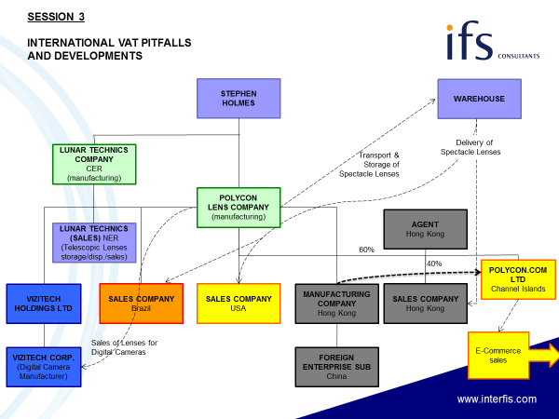

Session 4

Creating a Brand Manifesto & Digital Strategy

Polycon Lens Company has become a very successful manufacturing and trading group with substantial reserves of cash. Having sold the parallel company engaged in supplying the Armed Forces for a considerable profit, the business of the Group has used its expertise in higher quality optical lenses to manufacture camera lenses, thus diversifying beyond the manufacture and sale of inexpensive spectacles. Its principal customer is the Vizitech Corporation which purchases the lenses for its digital cameras. However, Mr Holmes has been informed that the company has cash flow problems and may be forced into liquidation, mainly because of inadequate turnover, high financing costs and the high cost of its raw material (the Polycon lenses). Mr Holmes has suggested to the directors of Polycon Lens Company that the Polycon sales companies now created (instead of using independent agents) could help develop potential turnover for Vizitech Corporation and that by eliminating the profit on the lenses and also eliminating the high finance costs, the corporation could become a very profitable acquisition for the company. This would also enable the sales subsidiaries to absorb their fixed costs against a much enlarged turnover, whilst also preserving the export sales of camera lenses which would otherwise collapse in the wake of a liquidation of Vizitech Corporation.

The business of Polycon Lens Company is now as diverse as a lens company can imagine. Its principal business is still the manufacture of low cost spectacles, and over the years the white label designer brand market has provided 60 per cent of the Group’s profits. The digital camera market accounts for another 20 per cent, whilst the lenses supplied to mobile phone manufacturers account for most of the remaining profits of the Group. However, the marketing director has been advising the Board to identify its products more closely using the same brand name, so that the Group can manufacture and sell its own designer label, which has the same brand name as the digital cameras (he considers the name Vizitech to be quite old fashioned). A group of marketing experts has come up with the name Eyemax for the entire range of the company’s products, including the digital cameras, and after consideration it is agreed that the corporate identity is changed to this brand name.

At the same time, a team of optometrists and plastic mould technicians have been developing a new type of zoom lens which does not have the bulk normally associated with such a lens and which can be built within a very lightweight digital camera. The name Eyemax would be ideal for this product. Thus the Group’s website is developed using the new brand and corporate literature. To maximise tax saving possibilities and to keep ownership of the new product in a separate entity, the Group has established Eyemax IPR as the company to own all rights to the new product, as well as to own and develop the brand with appropriate protection through trade mark registries. The company has now taken out worldwide patents in respect of the Eyemax camera and believes that the launch of the product will be successfully targeted for later that year. The Group also believes that the zoom lens can be licensed to competitors throughout the world who require the lenses for specific products which would not be in competition to the Eyemax. These licensing agreements could be entered into by an intermediary licensing company, Eyemax International Licensing Company but on a non exclusive basis, so that the Eyemax Group can enter the local market at a later stage to obtain market share for products which it currently does not envisage selling. Alternatively, Eyemax International could enter into franchise agreements with local distributors who would be able to market their products using the zoom lens manufactured by the Eyemax Group and using the brand name Eyemax as well.

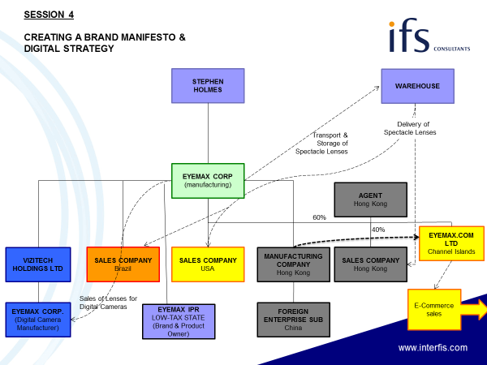

Session 5

Investor Requirements and Financing Techniques

The Group has further targets like Vizitech in mind, but now needs to consider its capital raising possibilities, and the directors are encouraged to consider various alternatives including an initial public offering of its shares on a European stock exchange. However, it is not considered that the present jurisdiction of Polycon is an appropriate jurisdiction for a listed company which wants to clearly demonstrate fiscal transparency and corporate governance, and therefore the directors are encouraged to consider the creation of an overall holding company in a more acceptable jurisdiction.

Subject to tax considerations, it may be beneficial for the holding company to acquire certain of the Polycon Lens Company subsidiaries, and indeed Vizitech Holdings could be transferred to the holding company without tax consequences for Vizitech. In this way, the Group can ensure the minimum possible withholding tax consequences on distribution of profits from worldwide subsidiaries through to the potential IPO Investors, thereby maximising the capital value of the Group if tax leakage is minimised. The directors also need to be sure that there is minimum corporate tax in the jurisdiction of the holding company chosen both as regards income receipts and capital gains on disposal of subsidiaries. In any event, Mr Holmes does not believe that the original Polycon office is adequate enough for a corporate headquarters, nor are some of the directors, and believes that a relocation of some of the management team into smart offices in the jurisdiction of the holding company may enable the group to attract more sophisticated management than hitherto.

Having capitalised the company sufficiently from its IPO, the new CFO located at the company’s headquarters in the holding company jurisdiction suggests that he is able to leverage further acquisitions, or engage in suitable joint venture agreements, through debt finance, and recommends the establishment of an appropriate finance company within the Group. This company will be responsible for raising the necessary finance and for utilising existing retained earnings in the most tax efficient way. The company may also be able to reduce Group taxation through interest deductions from those companies in high tax jurisdictions which require further finance to develop their business. As CFO, he will have an understanding of international money markets which would also enable surplus funds to be invested in the most tax efficient way. One of them is the immediate purchase of the Hong Kong agent’s 40 per cent shareholding in the Hong Kong sales subsidiary at a good profit to the agent, but enabling the Group to control and develop the business in its own way rather than in the immediate cash flow requirements of the agent.

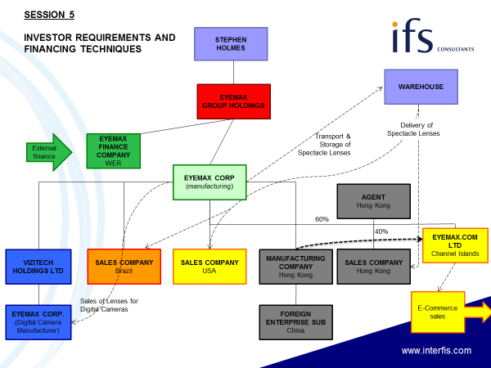

Session 6

Engaging with Partners in Overseas Joint Venture Agreements

The Eyemax technicians have been working for years on developing a concave lens of massive proportions to attract the sun’s rays and focus them into a power plant with maximum intensity, avoiding the dilution of power that has traditionally come from solar panels and increasing energy capture forty -fold. The “solar lens bowl” has been admired by energy authorities throughout the world, and firm orders would be placed for the electricity that could be generated from the power plants once the solar lens bowls were in place. However, the costs of manufacturing these bowls, which have a forty foot diameter, are extremely high, and those together with the costs of the relevant plants are greater than the resources available to the Eyemax Group. Nevertheless, because of the global benefits that can be achieved, the Board of Eyemax want to pursue this business through a separate organisation set up for this purpose.
It has been suggested that Eyemax creates a private equity fund established as a Cayman Islands entity which would attract the finance required to acquire the solar bowls in sites made available to the Fund by relevant regional authorities, as well as to maintain them once in situ to maximum efficiency. The private equity fund would establish its own corporate organisation which would have contracts with the Eyemax Group for the manufacture and supply of the solar lens bowls. A management team would need to be employed which would have experience in renewable energy, and who would take over the initial contacts with regional energy authorities so that predetermined sales can be effected in advance of manufacture of the solar lens bowls.
Rather than dilute the management expertise currently employed in the principal Eyemax business, the directors are considering joint venture arrangements with large utility companies whose expertise in energy distribution would be crucial to the success of the new operation. Eyemax key personnel are encouraged to discuss the potential for the solar bowls on a confidential basis with prospective partners.

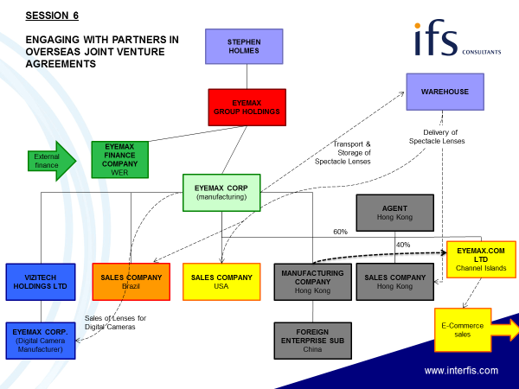

Session 7

International Tax Issues and Exit Strategies

Throughout the journey of Polycon through Eyemax to the Private Equity Fund, there are a myriad of international tax issues which need to be considered at each stage. Experts from various countries including the US, UK and major European jurisdictions will discuss how their countries may be utilised throughout the journey and what pitfalls and problems may be experienced as a result of double tax treaty issues and anti-avoidance legislation.

